Documentation Prototype AR

This is an HTML document that uses the A-Frame and AR.js libraries to create an augmented reality scene. The scene is rendered in a browser using a webcam as the tracking source. Here is a breakdown of the different parts of the code:

The <meta> tag specifies the viewport settings for the page.

The <script> tags load the necessary libraries for the AR scene, including A-Frame and AR.js, as well as two gesture detection scripts.

The <body> tag sets the margins and overflow for the page.

The <a-scene> tag is the root element for the AR scene. It includes various attributes that define the scene's settings, such as disabling the VR mode UI and loading screen, enabling the AR.js library, and specifying the tracking method and source type.

Inside the <a-scene> tag is an <a-marker> tag that defines the marker used for tracking. The type attribute is set to "pattern" and the preset attribute is set to "custom", indicating that a custom marker pattern is being used. The url attribute specifies the location of the marker pattern file, and the raycaster attribute specifies which objects should be affected by the raycaster component. The emitevents attribute is set to "true", which means the marker emits events that can be detected by other elements in the scene.

Inside the <a-marker> tag are three child elements: an <a-text> element, an <a-image> element, and two <a-sphere> elements. These are 3D objects that are positioned relative to the marker. The <a-text> element displays the text "Prototype AR" in yellow color, and is positioned above the marker. The <a-image> element displays an image and has a click event attached to it, which rotates the image when clicked. The <a-sphere> elements are colored spheres that also have a rotation animation.

The <a-entity> tag at the end of the scene defines the camera that is used to render the scene from the user's perspective.

Overall, this code creates a simple AR scene with a custom marker pattern, some 3D objects, and gesture detection.

Ar.js Documentation: <https://ar-js-org.github.io/AR.js-Docs/>

Ar.js Studio: <https://ar-js-org.github.io/studio/>

Github link to variety of examples: <https://github.com/stemkoski/AR.js-examples>

Variety of examples: <https://stemkoski.github.io/AR.js-examples/index.html>  
  
Github pages Documentation: <https://docs.github.com/en/pages>

Tutorial

**Step by step**

Step 1: Set up your project

To create an augmented reality scene, you'll need to have a web page with the A-Frame and AR.js libraries included. You can download these libraries from their respective websites and include them in your HTML file. Here's an example of how to include them using CDNs:

<!DOCTYPE html>

<html>

<head>

<meta charset="UTF-8">

<title>AR Scene</title>

<meta name="viewport" content="width=device-width, initial-scale=1.0">

<script src="https://aframe.io/releases/1.0.4/aframe.min.js"></script>

<script src="https://raw.githack.com/AR-js-org/AR.js/master/aframe/build/aframe-ar.js"></script>

</head>

<body>

<!-- AR scene code goes here -->

</body>

</html>

Step 2: Set up the scene

Inside the body of your HTML file, you'll need to create an <a-scene> element that defines the AR scene. This element should have several attributes that specify the settings for the scene. Here's an example:

<a-scene

vr-mode-ui="enabled: false;"

loading-screen="enabled: false;"

arjs="trackingMethod: best; sourceType: webcam; debugUIEnabled: false;" embedded>

<!-- AR scene content goes here -->

</a-scene>

Step 3: Add a marker

Next, you need to define a marker that will be used to track the AR content. In this example, the marker is defined using an <a-marker> element with a pattern type. The marker is also given an ID of "animated-marker" for reference later on. Additionally, the marker has a URL that points to an image file that is used to detect the marker in the real world. The marker also has a raycaster attribute that specifies which objects the cursor will intersect with, and emitevents attribute that enables the marker to emit events, and a cursor attribute that specifies the type of cursor to use. Finally, the <a-marker> element has several child elements including an <a-text> element, an <a-image> element, and two <a-sphere> elements.

<a-marker

id="animated-marker"

type="pattern"

preset="custom"

url="assets/marker.patt"

raycaster="objects: .clickable"

emitevents="true"

cursor="fuse: false; rayOrigin: mouse;"

id="markerA">

<!-- Marker content goes here -->

</a-marker>

Step 4: Add content to the marker

Inside the <a-marker> element, you can add any 3D elements that you want to display when the marker is detected. In this example, an <a-text> element with the value "Prototype AR" is added, along with an <a-image> element that displays an image, and two <a-sphere> elements that are colored blue and red respectively. The <a-image> element also has a rotation animation that rotates the image around its Y-axis.

<a-marker >

<!-- Add text element -->

<a-text value="Prototype AR"

gesture-detector

color="yellow"

position="0 30 0"

rotation="-90 0 0"

scale="5 5 5"

font="https://cdn.aframe.io/fonts/Roboto-msdf.json">

</a-text>

<!-- Add image element -->

<a-image

src="assets/asset.png"

scale="3 1 1"

class="clickable"

rotation="-180 0 0"

gesture-handler

animation="property: rotation; to: 0 180 0; loop: true; easing: linear">

</a-image>

<!-- Add sphere elements -->

<a-sphere position="1.5" color="blue" radius ="0.15" gesture-handler>

<a-animation

attribute="color"

dur="10000"

from="blue"

to="orange"

repeat="indefinite">

</a-animation>

</a-sphere>

<a-sphere position="-1.5" color="red" radius ="0.15" gesture-handler>

<a-animation

attribute=" color"

dur="10000"

from="red"

to="green"

repeat="indefinite">

</a-animation>

</a-sphere>

</a-marker>

Step 5: Add a camera

To view the AR scene, you need to add a camera entity to the <a-scene> element. This can be done using the <a-entity> element with the camera attribute:

<a-entity camera></a-entity>

Step 6: Add gesture detection and handling

To enable gesture detection and handling in the AR scene, you need to include the gesture detector and handler scripts. These scripts are included using two <script> elements that link to the gesture-detector.js and gesture-handler.js files respectively. Additionally, the <a-scene> element has a gesture-detector attribute that enables gesture detection and a gesture-handler attribute that enables gesture handling.

**Ar.js Code Generator**

Step 1: Go to the following link: <https://ar-js-org.github.io/studio/>

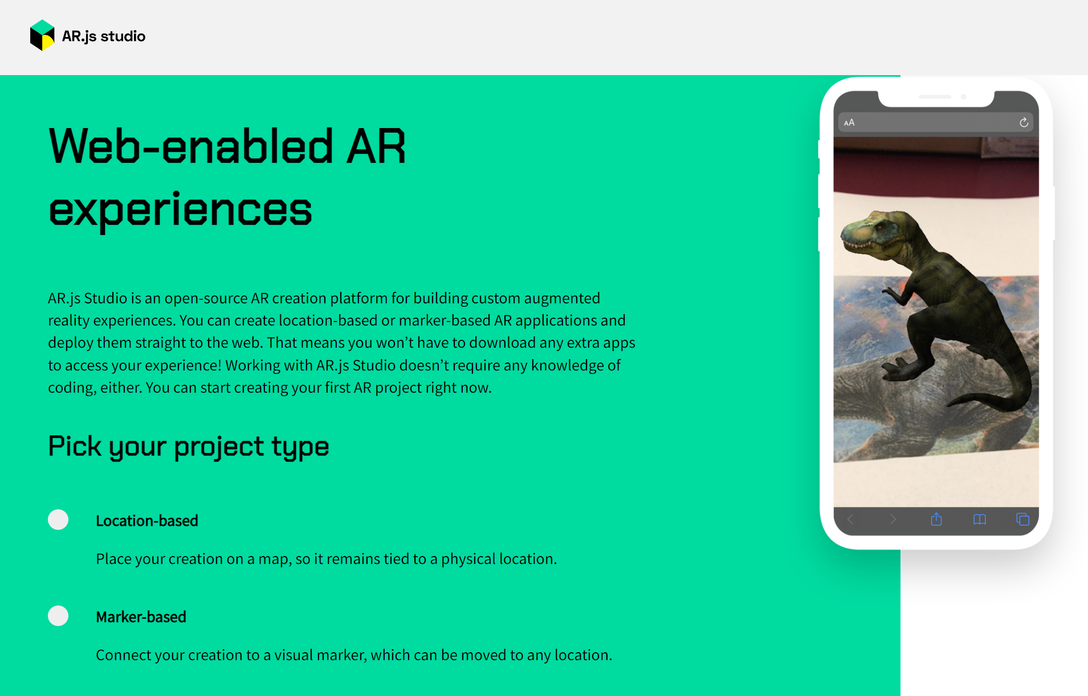

Step 2: Choose the "Marker-based" option and click on "Start Building."

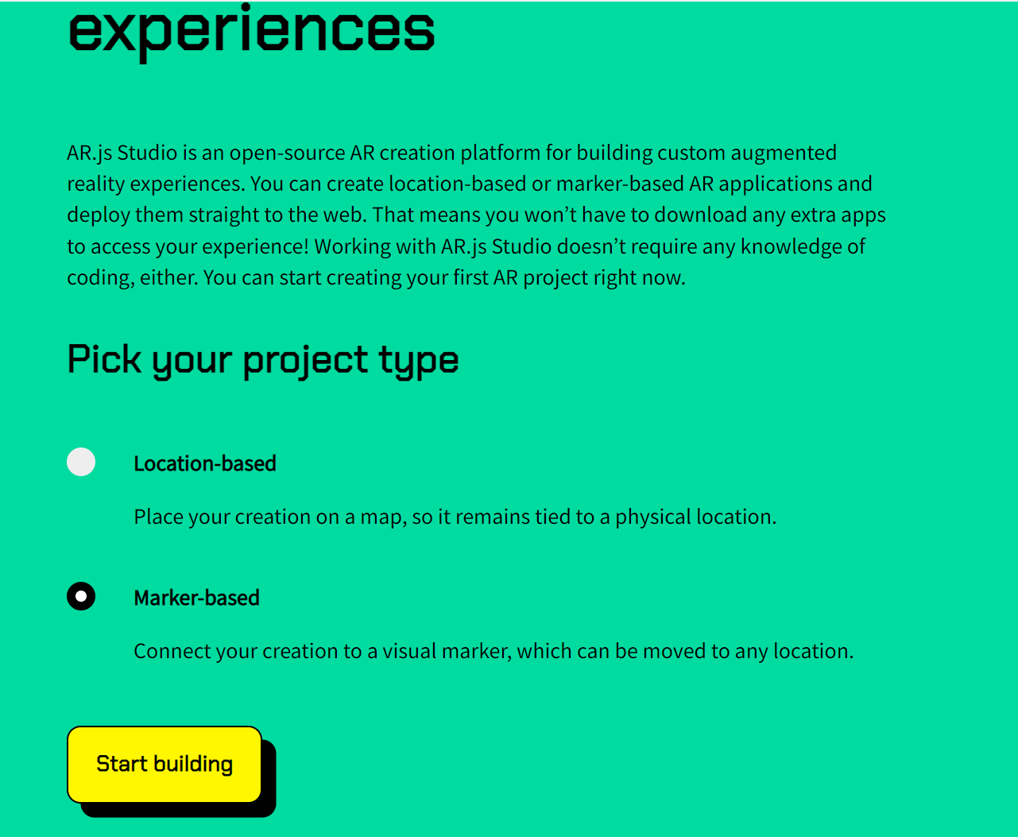

Step 3: Upload an image of the marker you want to use, and make sure to download it for future reference.

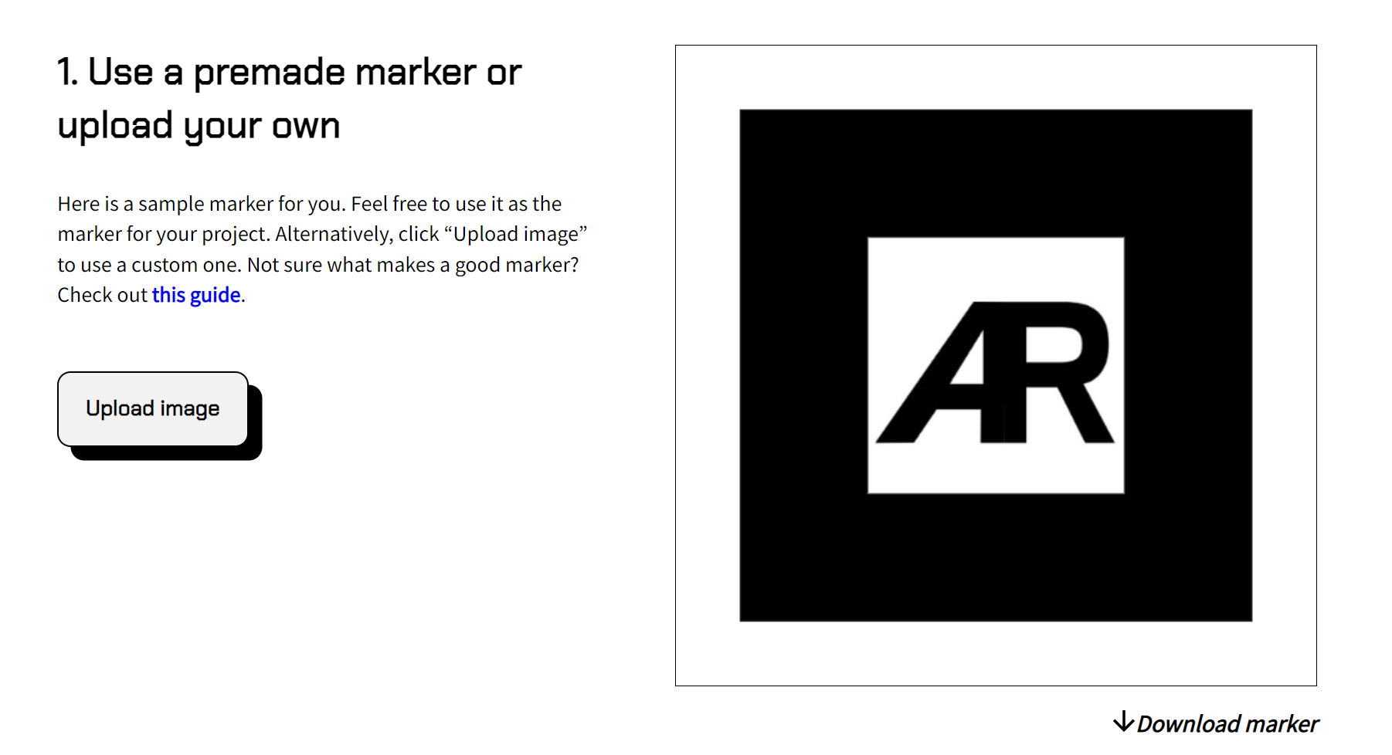

Step 4: Choose the content that you want your marker to display.

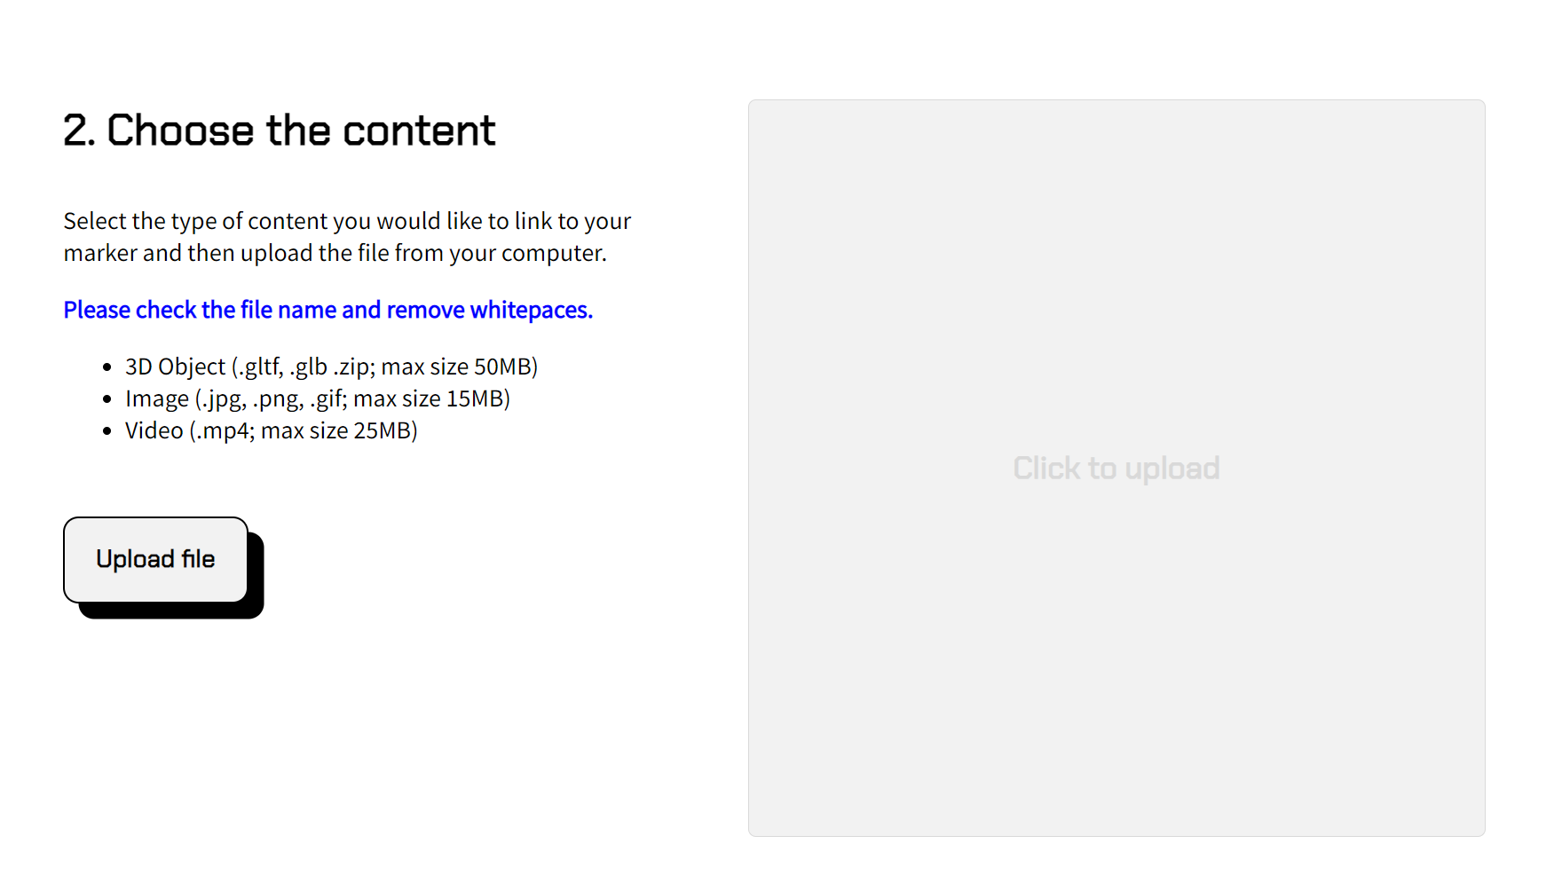

Step 5: Download the package.

Step 6: Export your project to GitHub so that you can use it on other platforms with GitHub Pages. Make sure that the main HTML file is named "index.html."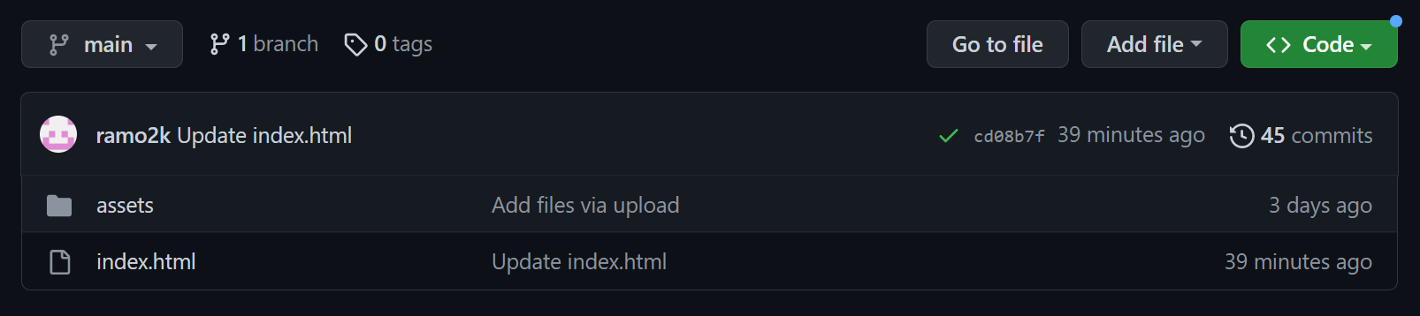

Step 7: Go to "Settings" in the top right of the repository.  
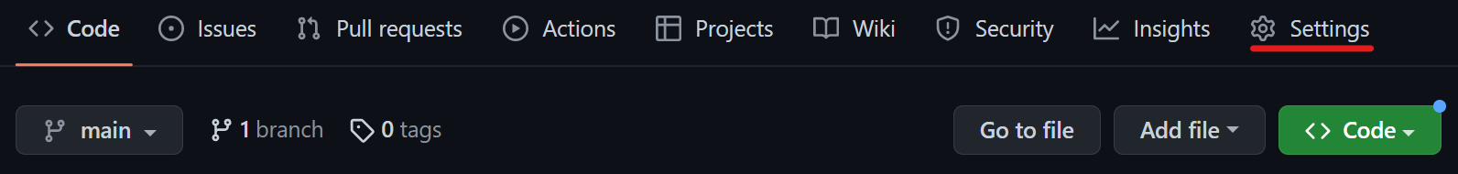

Step 8: Click on the "Pages" tab.

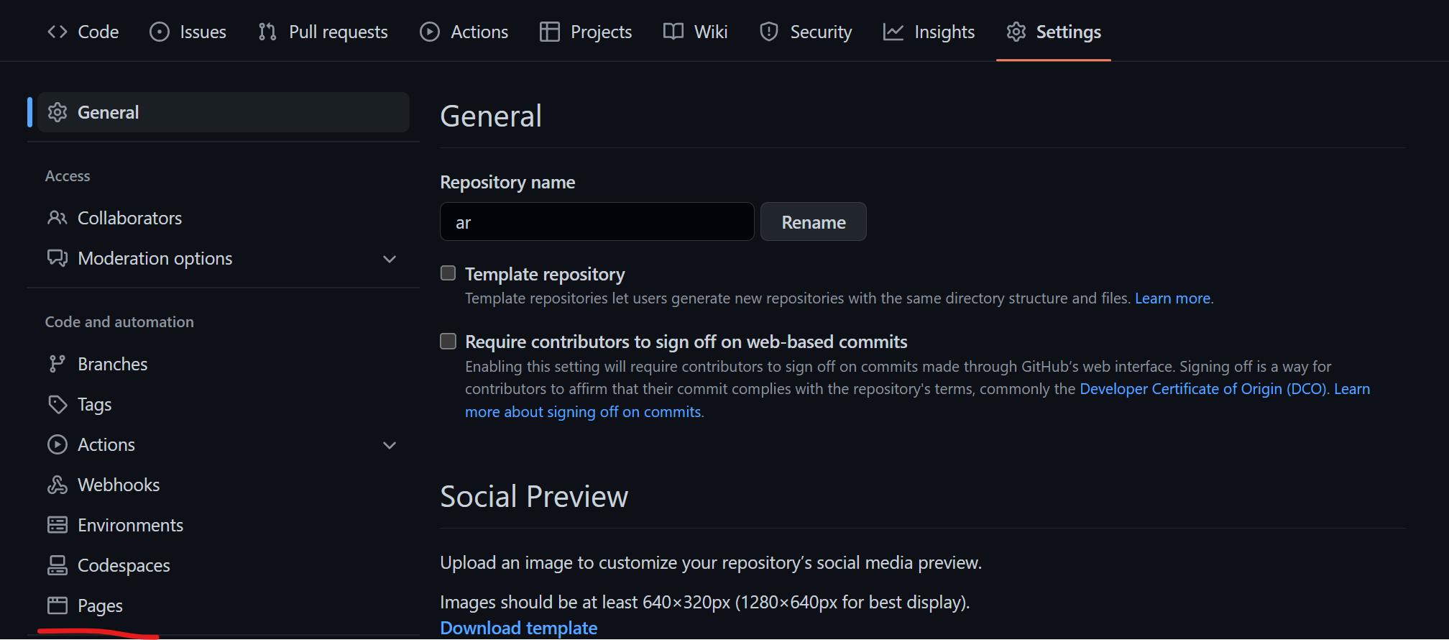

Step 9: Choose the main branch in the branch options and click on "Save."

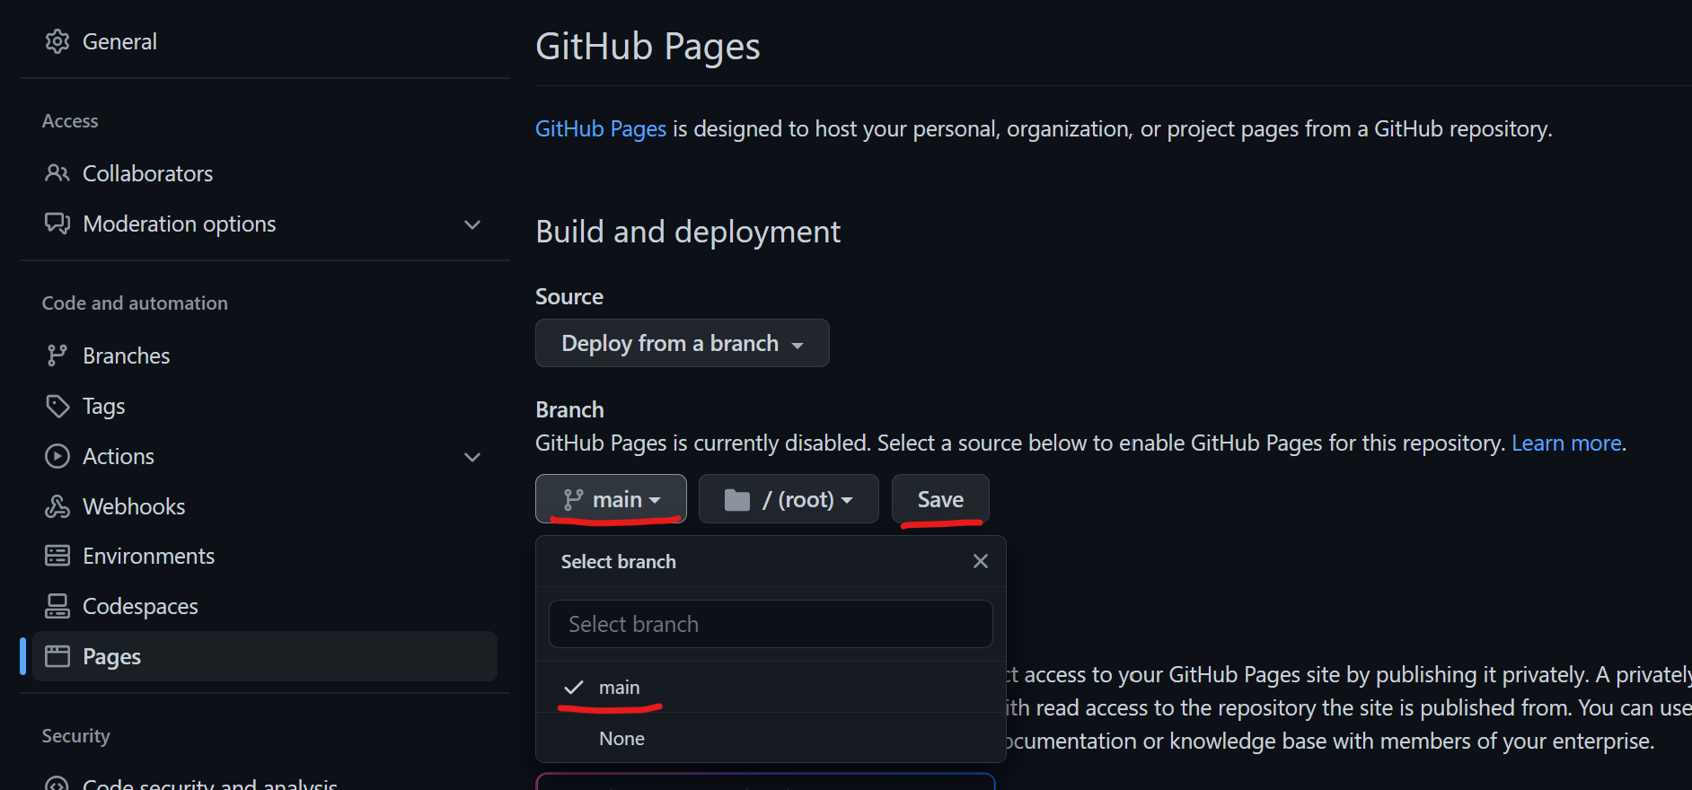

Step 10: Choose a custom domain name and click on "Save."

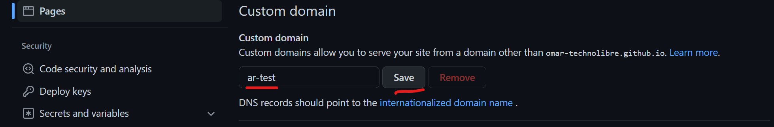

Step 11: Click on the generated link to access the website.  
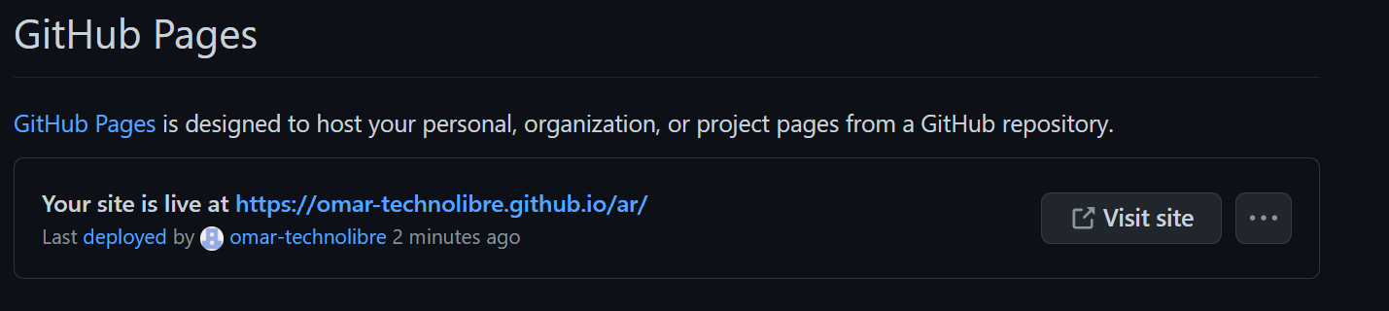

Step 12: Log in to GitHub from other platforms and navigate to the generated link above. Display the downloaded marker in front of your camera to see the results.

